Website URL: <http://imadweb.centralus.cloudapp.azure.com/web_app/project4/rudys_home.html>

GitHub URL: <https://github.com/imad-97/rasmussen-dev>

Desktop view: 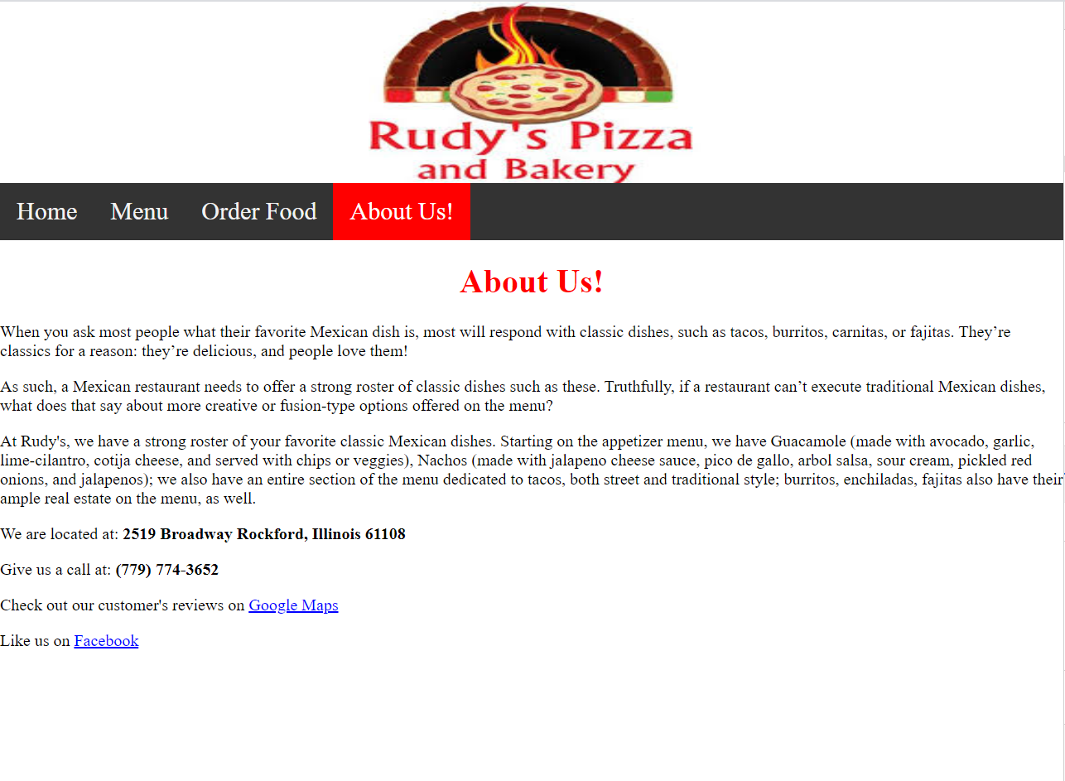

Galaxy S5 view: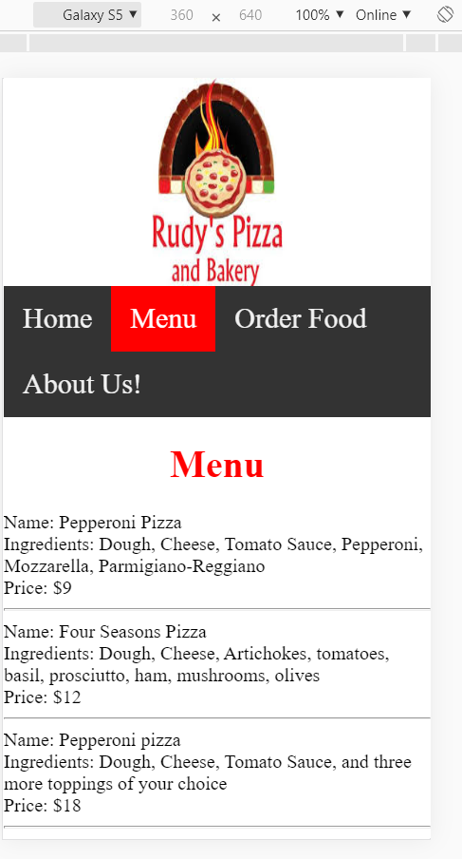

Pixel 2xl view: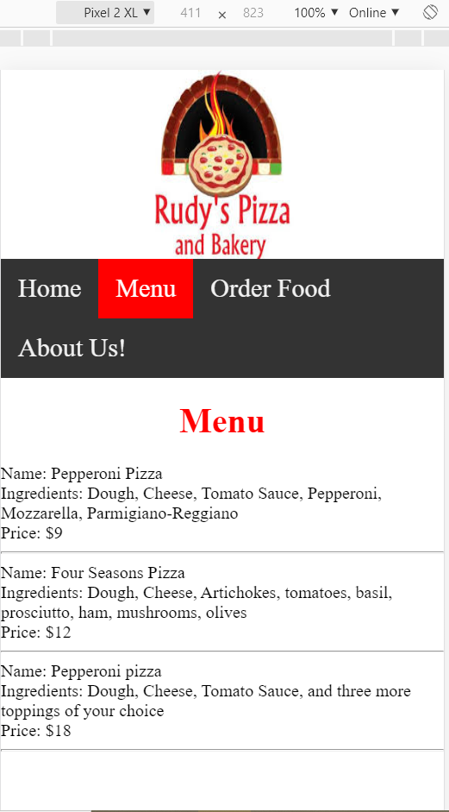

iPad view: 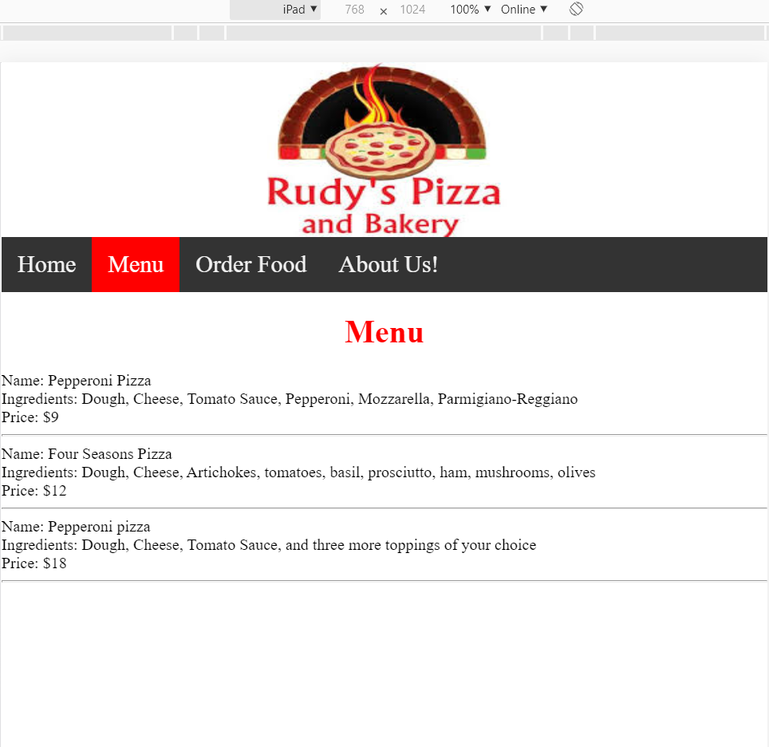

iPad Pro view: 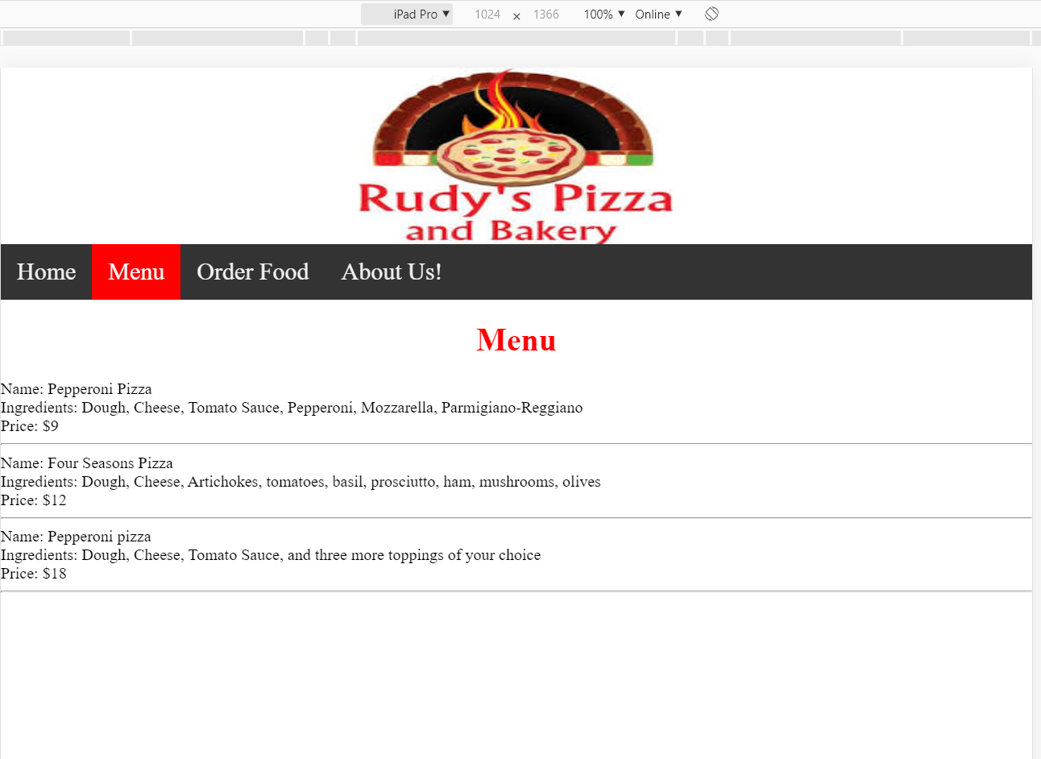

iPhone 6/7/8 plus view: 